1. **File Server**: Any Server which is capable to reading, editing, deleting a file.  
   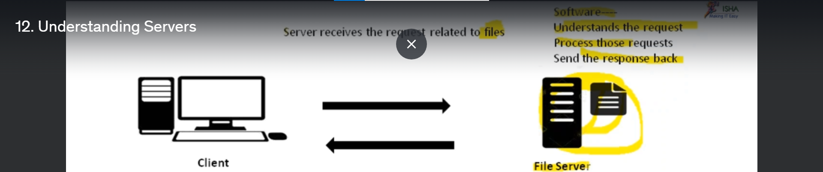
2. **Print Server**: A server that understands requests only related to prints.  
   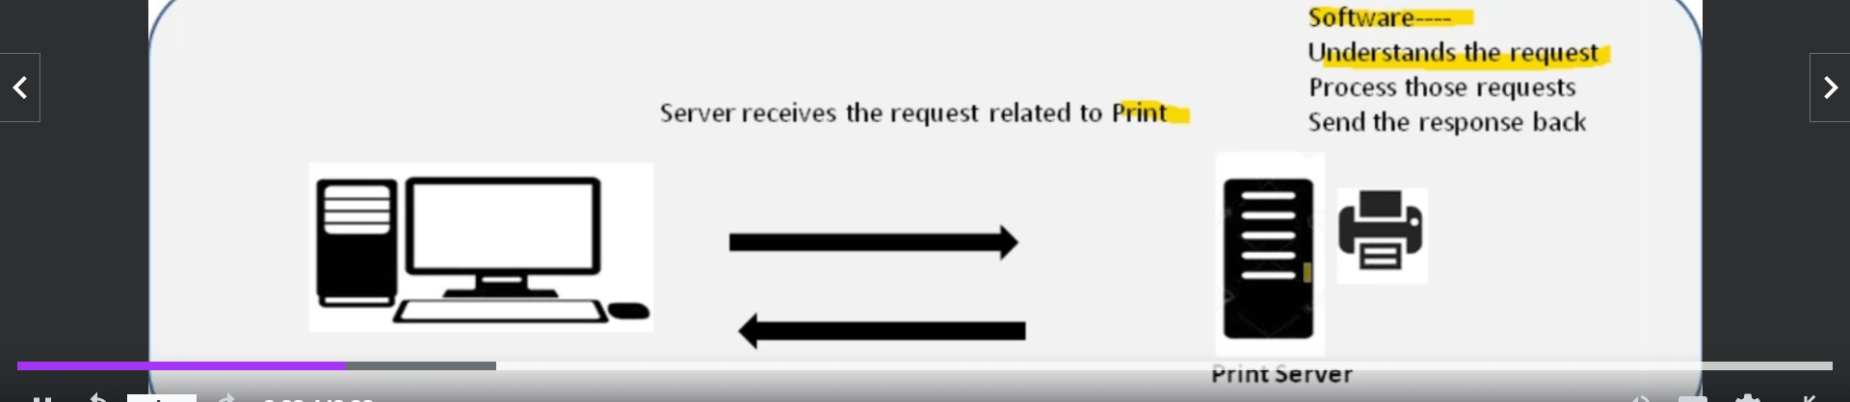
3. **Database Server**: Server receives the request related to only data.
   1. **Examples**:
      1. **Oracle**.
      2. **DB2**

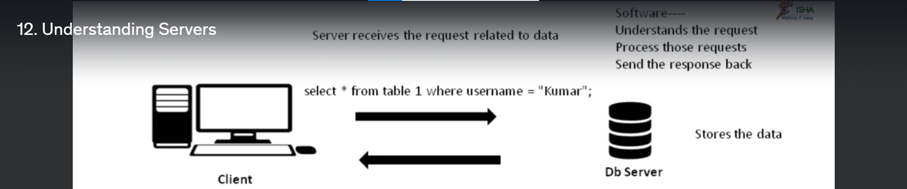

1. **Application**:  
   Suppose, we have an App Gmail installed on some computer and we are sending requests to that app and that app responds to our requests properly then we say that is app server.   
   Application server has only the code developed by the Developers.   
   